# 

# Introduction to Software Testing

Software testing is nothing but an art of investigating software to ensure that its quality under test is in line with the requirement of the client. Software testing is carried out in a systematic manner with the intent of finding defects in a system. It is required for evaluating the system. As the technology is advancing we see that everything is getting digitized. You can access your bank online, you can shop from the comfort of your home, and the options are endless. Have you ever wondered what would happen if these systems turn out to be defective? One small defect can cause a lot of financial loss. It is for this reason that software testing is now emerging as a very powerful field in IT.

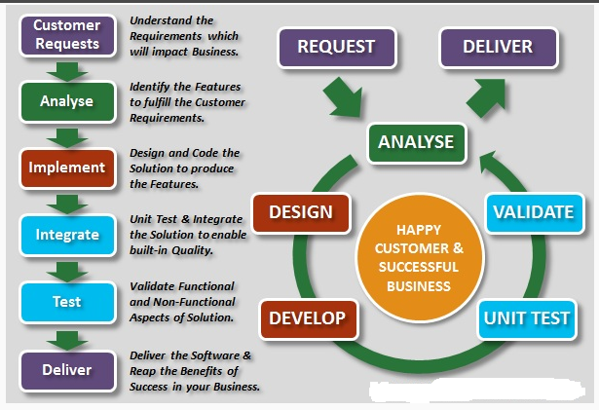

1. Software testing is required to check the reliability of the software
2. Software testing ensures that the system is free from any bug that can cause any kind of failure
3. Software testing ensures that the product is in line with the requirement of the client
4. It is required to make sure that the final product is user friendly
5. At the end software is developed by a team of human developers all having different viewpoints and approach. Even the smartest person has the tendency to make an error. It is not possible to create software with zero defects without incorporating software testing in the development cycle.
6. No matter how well the software design looks on paper, once the development starts and you start testing the product you will definitely find lots of defects in the design.

You cannot achieve software quality without software testing. Even if testers are not involved in actual coding they should work closely with developers to improve the quality of the code. For best results it is important that software testing and coding should go hand in hand.

**Cost of Software Quality** Cost of quality is important because when you decide to conduct software testing for your product you are actually going to invest your time, money and effort in getting quality checks done. By conducting an analysis of cost of software quality you would know what the return on that investment (ROI) is.

